12x40W LED Wash Zoom Moving Light

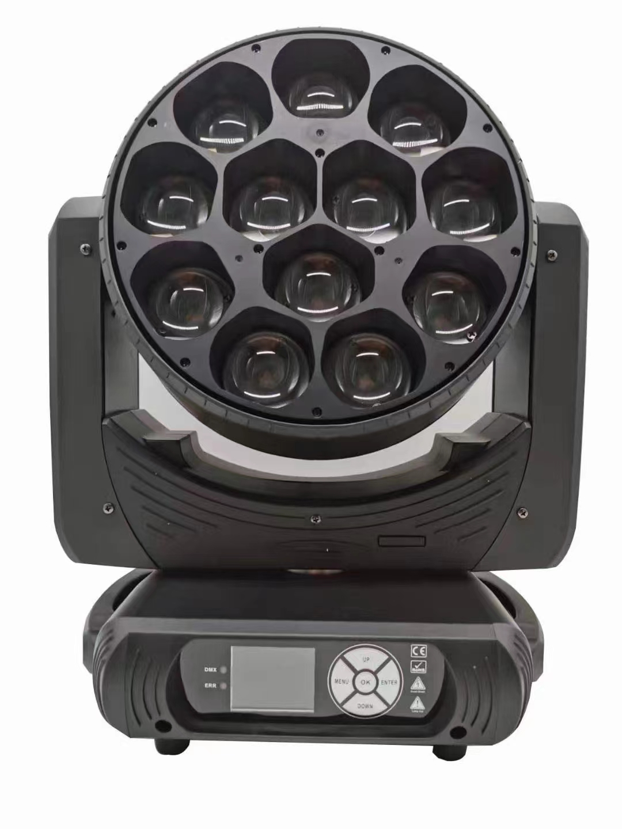

User Manual
Professional Entertainment Technology

1. Safety Instructions

Please read carefully the instruction, which includes important information about the installation, usage and maintenance.
WARNING

- Please keep this User Guide for future consultation. If you sell the unit to another user, be sure that they also receive this instruction booklet.
- Unpack and check carefully there is no transportation damage before using the unit.
- Before operating, ensure that the voltage and frequency of power supply match the power requirements of the unit.
- It’s important to ground the yellow/green conductor to earth in order to avoid electric shock.
- The unit is for indoor use only. Use only in a dry location.
- The unit must be installed in a location with adequate ventilation, at least 50cm from adjacent surfaces. Be sure that no ventilation slots are blocked.
- Disconnect main power before replacement or servicing.
- Make sure there are no flammable materials close to the unit while operating as it is fire hazard.
- Use safety cable when fixes this unit. DO NOT handle the unit by taking its head only, but always by taking its base.
- Maximum ambient temperature is Ta: 40℃. DO NOT operate it where the temperature is higher than this.
- Unit surface temperature may reach up to 85℃. DO NOT touch the housing bare-hand

during its operation. Turn off the power and allow about 15 minutes for the unit to cool down before replacing or serving.
- In the event of serious operating problem, stop using the unit immediately. Never try to repair the unit by yourself. Repairs carried out by unskilled people can lead to damage or malfunction. Please contact the nearest authorized technical assistance center. Always use the same type spare parts.
- DO NOT touch any wire during operation as high voltage might be causing electric shock.

Warning:

- To prevent or reduce the risk of electrical shock or fire, do not expose the unit to rain or moisture.
- DO NOT open the unit within five minutes after switching off.
- The housing, the lenses, or the ultraviolet filter must be replaced if they are visibly damaged.

Caution:
There are no user serviceable parts inside the unit. DO NOT open the housing or attempt any repairs yourself. In the unlikely event your unit may require service, please contact your nearest dealer.
If using a 230V 50Hz power supply, DO NOT connect in series more than 11 units; use another main supply for the next 11 fixtures.
If using a 120V 60Hz power supply, DO NOT connect in series more than 5 units; use another main supply for the next 5 fixtures.

Installation:

The unit should be mounted via its screw holes on the bracket. Always ensure that the unit is firmly fixed to avoid vibration and slipping while operating. And make sure that the structure to which you are attaching the unit is secure and is able to support a weight of 10 times of the unit’s weight. Also always use a safety cable that can hold 12 times of the weight of the unit when installing the fixture.

Technical Specifications

Led Source
Light Source: 12x40W 4inl RGBW LED
Zoom Range : 8°-45°
Dimming : 0- 100° smooth dimming
CCT : 2500-8000k ( adjustable )
Strobe : 0-20Hz
Luminous : 8212lm / 10m 2.8°

Control
DMX Channel : 11CH / 17CH / 18CH / 58CH
Control Mode : DMX512, Master-Slave , Sound Slave

Pan/Tilt
Pan/Tilt:540°/270°
Pan/Tilt Resolution:16bit

Construction
Data In/Out : 3-pin&5-pin XLP
Power in/Out : Power Con in / out
Protection Rating: IP20

POWER
Power Voltage : AC100-240V,50/60Hz
Power Consumption: 600W
Working temperature: -20 ~ 40°

DIMENSIONS AND WEIGHT
Dimensions : 470x400x270 mm

3. MENU
Primary menu | Second-level menu |  | Three-level menu /Parameter | Parameter
DmxAddr | 001 - 512
Fix Set | Ch Mode |  | 11CH/17CH/18CH/58CH
Fix Set | Run Mode |  | DMX/Host
Fix Set | Pan Inv |  | Close/Open
Fix Set | Tilt Inv |  | Close/Open
Manual | Pan |  | 0 - 255
Manual | Pan Fine |  | 0 - 255
Manual | Tilt |  | 0 - 255
Manual | Tilt Fine |  | 0 - 255
Manual | . |  | 0 - 255
Manual | . |  | 0 - 255
Manual | . |  | 0 - 255
Fix Info | TimeInfo |  | Cur Time | xxxh
Fix Info |  |  | Show Time | xxxh
Fix Info |  |  | PowerCnt | xxx
Fix Info | SenSor |  | Pan | OK/NG
Fix Info |  |  | Tilt | OK/NG
Fix Info |  |  | Zoom | OK/NG
Fix Info |  |  | Temp | OK/NG
Fix Info |  |  | Fan | OK/NG
Fix Info | TempInfo |  | Temprat | xxx C
Fix Info |  |  | FanSpeed | xxxx RPM
Fix Info | Soft Ver |  | Panel | Vx.xxx
Fix Info |  |  | Motor | Vx.xxx
Fix Info |  |  | Dimmer | Vx.xxx
Home Set | Password |  | 0 - 255
Home Set | Pan |  | 0 - 255
Home Set | Tilt |  | 0 - 255
Home Set | Zoom |  | 0 - 255
Home Set | Red |  | 0 - 255
Home Set | Green |  | 0 - 255
Home Set | Blue |  | 0 - 255
Home Set | White |  | 0 - 255
FixReset | Reset |  | Cance/Run
FixReset | Factory |  | Cance/Run
Display | Language |  | EN/CH
Display | DispFlip |  | Open/Close
Display | DispMode |  | Show/60s

4.
channel thoroughfare passage
Standard | Extended | Graphic | HSImodel | Channelname | Channel  value | Channel content
1 | 1 | 1 | 1 | Pan | 0 - 255 | Horizontal rotation
2 | 2 | 2 | 2 | PanFine | 0 - 255 | Horizontal fine-tuning
3 | 3 | 3 | 3 | Tilt | 0 - 255 | Vertical rotation
4 | 4 | 4 | 4 | TiltFine | 0 - 255 | Vertical fine-tuning
5 | 5 | 5 | 5 | PTSpeed | 0 - 255 | Motor speed
6 | 6 | 6 | / | Dim | 0 - 255 | Dimming
7 | 7 | / | / | DimFine | 0 - 255 | Dimming fine
8 | 8 | 7 | 6 | Strobe | 0 - 3 | Close
 |  |  |  |  | 4 - 103 | Regular strobe,  speed from slow to fast
 |  |  |  |  | 104 - 107 | Open
 |  |  |  |  | 108 - 207 | Pulse strobe, the speed  changes from slow to fast
 |  |  |  |  | 208 - 212 | Open
 |  |  |  |  | 213 - 225 | Random slow strobe
 |  |  |  |  | 226 - 238 | Randon medium-speedstrobe
 |  |  |  |  | 239 - 251 | Random fast strobe
 |  |  |  |  | 252 - 255 | Open
9 | / | 8 | / | Red | 0 - 255 | Red
10 | / | 9 | / | Green | 0 - 255 | Green
11 | / | 10 | / | Blue | 0 - 255 | Blue
12 | / | 11 | / | White | 0 - 255 | White
/ | / | / | 7 | Hue | 0 - 255 | Chromaticity
/ | / | / | 8 | Saturation | 0 - 255 | Saturation
/ | / | / | 9 | Intensiyt | 0 - 255 | Brightness
/ | 9 | / | / | R1 | 0 - 255 | Red lamp beads1
/ | 10 | / | / | G1 | 0 - 255 | Green lamp beads1
/ | 11 | / | / | B1 | 0 - 255 | Blue lamp beads1
/ | 12 | / | / | W1 | 0 - 255 | White lamp beads1
/ | 13 | / | / | R2 | 0 - 255 | Red lamp beads2
/ | 14 | / | / | G2 | 0 - 255 | Green lamp beads2
/ | 15 | / | / | B2 | 0 - 255 | Blue lamp beads2
/ | 16 | / | / | W2 | 0 - 255 | White lamp beads2
/ | 17 | / | / | R3 | 0 - 255 | Red lamp beads3
/ | 18 | / | / | G3 | 0 - 255 | Green lamp beads3
/ | 19 | / | / | B3 | 0 - 255 | Blue lamp beads3
/ | 20 | / | / | W3 | 0 - 255 | White lamp beads3
/ | 21 | / | / | R4 | 0 - 255 | Red lamp beads4
/ | 22 | / | / | G4 | 0 - 255 | Green lamp beads4
/ | 23 | / | / | B4 | 0 - 255 | Blue lamp beads4
/ | 24 | / | / | W4 | 0 - 255 | White lamp beads4
/ | 25 | / | / | R5 | 0 - 255 | Red lamp beads5
/ | 26 | / | / | G5 | 0 - 255 | Green lamp beads5
/ | 27 | / | / | B5 | 0 - 255 | Blue lamp beads5
/ | 28 | / | / | W5 | 0 - 255 | White lamp beads5
/ | 29 | / | / | R6 | 0 - 255 | Red lamp beads6
/ | 30 | / | / | G6 | 0 - 255 | Green lamp beads6
/ | 31 | / | / | B6 | 0 - 255 | Blue lamp beads6
/ | 32 | / | / | W6 | 0 - 255 | White lamp beads6
/ | 33 | / | / | R7 | 0 - 255 | Red lamp beads7
/ | 34 | / | / | G7 | 0 - 255 | Green lamp beads7
/ | 35 | / | / | B7 | 0 - 255 | Blue lamp beads7
/ | 36 | / | / | W7 | 0 - 255 | White lamp beads7
/ | 37 | / | / | R8 | 0 - 255 | Red lamp beads8
/ | 38 | / | / | G8 | 0 - 255 | Green lamp beads8
/ | 39 | / | / | B8 | 0 - 255 | Blue lamp beads8
/ | 40 | / | / | W8 | 0 - 255 | White lamp beads8
/ | 41 | / | / | R9 | 0 - 255 | Red lamp beads9
/ | 42 | / | / | G9 | 0 - 255 | Green lamp beads9
/ | 43 | / | / | B9 | 0 - 255 | Blue lamp beads9
/ | 44 | / | / | W9 | 0 - 255 | White lamp beads9
/ | 45 | / | / | R10 | 0 - 255 | Red lamp beads10
/ | 46 | / | / | G10 | 0 - 255 | Green lamp beads10
/ | 47 | / | / | B10 | 0 - 255 | Blue lamp beads10
/ | 48 | / | / | W10 | 0 - 255 | White lamp beads10
/ | 49 | / | / | R11 | 0 - 255 | Red lamp beads11
/ | 50 | / | / | G11 | 0 - 255 | Green lamp beads11
/ | 51 | / | / | B11 | 0 - 255 | Blue lamp beads11
/ | 52 | / | / | W11 | 0 - 255 | White lamp beads11
/ | 53 | / | / | R12 | 0 - 255 | Red lamp beads12
/ | 54 | / | / | G12 | 0 - 255 | Green lamp beads12
/ | 55 | / | / | B12 | 0 - 255 | Blue lamp beads12
/ | 56 | / | / | W12 | 0 - 255 | White lamp beads12
13 | / | / | / | CCT | 0 - 255 | Color temperature  adjustment
14 | / | 12 | / | Macro | 0 - 255 | Color macro
/ | / | 13 | / | Shape | 0 | Close
 |  |  |  |  | 1 - 6 | The lamp bead 1 is on
 |  |  |  |  | 7 -- 13 | Lamp beads 2 are on
 |  |  |  |  | 14 - 20 | The lamp beads are 3 on
 |  |  |  |  | 21 -27 | The lamp beads are on 4
 |  |  |  |  | 28 - 34 | The lamp beads are  5 bright.
 |  |  |  |  | 35 - 41 | The lamp beads are 6 on
 |  |  |  |  | 42 - 48 | The lamp beads are 7 on
 |  |  |  |  | 49 - 55 | The lamp beads are 8 on
 |  |  |  |  | 56 -62 | The lamp beads are 9 on
 |  |  |  |  | 63 - 69 | The lamp beads are 10 on
 |  |  |  |  | 70 - 76 | The lamp beads are 11 on
 |  |  |  |  | 77 - 83 | The lamp beads are 12 on
 |  |  |  |  | 84 - 90 | 3 pendulum static shapes1
 |  |  |  |  | 91 - 97 | 3 pendulum static shapes2
 |  |  |  |  | 98 - 104 | 3 pendulum static shapes3
 |  |  |  |  | 105 - 111 | 4 pendulum static shapes1
 |  |  |  |  | 112 - 118 | 4 pendulum static shapes2
 |  |  |  |  | 119 - 125 | 4 pendulum static shapes3
 |  |  |  |  | 126 - 132 | 3 inverted pendulum static shapes 1
 |  |  |  |  | 133 - 139 | 3 inverted pendulum static shapes 2
 |  |  |  |  | 140- 146 | 3 inverted pendulum static shapes 3
 |  |  |  |  | 147 -153 | 3 static patterns  in the middle
 |  |  |  |  | 154 -160 | 9 static patterns  in the outer ring
 |  |  |  |  | 161 - 167 | Static pattern of windmill
 |  |  |  |  | 168 -174 | Single flowing water  dynamic effect
 |  |  |  |  | 175 - 181 | 2 flowing water  dynamic effects
 |  |  |  |  | 182- 188 | 3 flowing water  dynamic effects
 |  |  |  |  | 189 - 195 | 3 inverted  pendulum flowing water dynamic effect
 |  |  |  |  | 196 -202 | Dynamic effect of 4  pendulum flowing water
 |  |  |  |  | 203 - 209 | Dynamic effect of 3  pendulum flowing water
 |  |  |  |  | 210 - 216 | Wavy dynamic running  water effect
 |  |  |  |  | 217 -223 | Windmill rotation effect
 |  |  |  |  | 224 - 230 | Dynamic effect of  petals blooming
 |  |  |  |  | 231 - 237 | Colorful petal blooming  effect
 |  |  |  |  | 238 - 244 | Colorful petal wave effect
 |  |  |  |  | 245 - 251 | Colored petal rotation  effect
 |  |  |  |  | 252 - 255 | Colorful rotation effect
/ | / | 14 | / | Speed | 0 - 255 | Graphic effect speed  selection
15 | / | / | / | Effect | 0 | Close
 |  |  |  |  | 1 - 100 | Dreamy effect
 |  |  |  |  | 101 - 200 | Wave effect
 |  |  |  |  | 201 - 255 | No effect
/ | / | 15 | / | ShapeBack | 0 - 255 | Graphic background  color selection
/ | / | 16 | / | BackDim | 0 - 255 | The brightness of the  background color is  from light to dark
16 | 57 | 17 | 10 | Zoom | 0 - 255 | Focusing
17 | 58 | 18 | 11 | Reset/Prog | 0 - 59 | No effect
 |  |  |  |  | 60 - 99 | All motor resets
 |  |  |  |  | 100 - 255 | No effect

5. Trouble shooting
Following are a few common problems that may occur during operation. Here are some suggestions for easy troubleshooting:
- The unit does not work, no light and the fan does not work
  - Check the connection of power and main fuse.
  - Measure the mains voltage on the main connector.
  - Check the power on LED.

- Not responding to DMX controller
  - DMX LED should be on. If not, check DMX connectors, cables to see if link properly.
  - If the DMX LED is on and no response to the channel, check the address settings and DMX polarity.
  - If you have intermittent DMX signal problems, check the pins on connectors or on PCB of the unit or the previous one.
  - Try to use another DMX controller.
  - Check if the DMX cables run near or run alongside to high voltage cables that may cause damage or interference to DMX interface circuit.
- One of the channels is not working well
  - The stepper motor might be damaged or the cable connected to the PCB is broken.
  - The motor’s drive IC on the PCB might be out of condition.

6. Fixture Cleaning
The cleaning of internal and external optical lenses and/or mirrors must be carried out periodically to optimize light output. Cleaning frequency depends on the environment in which the fixture operates: damp, smoky or particularly dirty surrounding can cause greater accumulation of dirt on the unit’s optics.
- Clean with soft cloth using normal glass cleaning fluid.
- Always dry the parts carefully.
- Clean the external optics at least every 20 days. Clean the internal optics at least every 30/60 days.

